**Assignment # 02**

**Probability & Statistics Spring 2020**

**Instructions:**

* Assignment must include the title page that contain your roll number, full name, section, date, and submission date etc.
* Solve each question step by step otherwise marks will be deducted.
* Calculations for questions 13 to 19 can be done on MS-Excel.
* Take snapshots of your assignment and convert it into PDF format.
* Submit assignment in PDF format via google drive link. The link will be provided later by the teacher.
* Deadline of submission will be follow strictly.

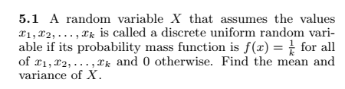

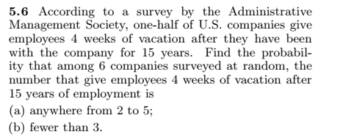

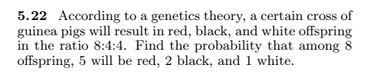

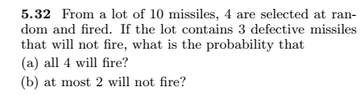

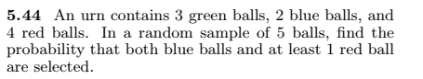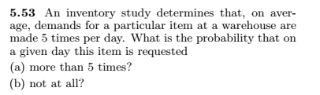

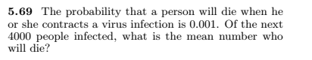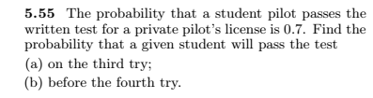

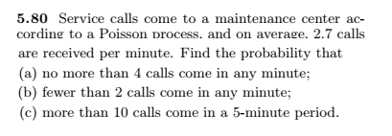

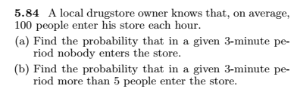

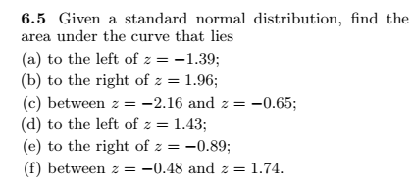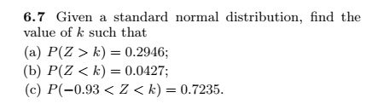

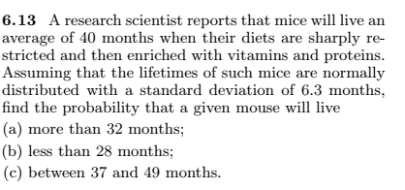

**For exercises 13 through 16, perform each of the following steps.**

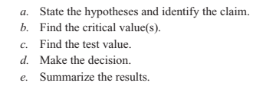

**Q 13)**

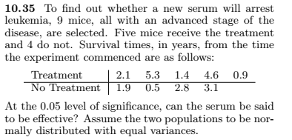

**Q14)**

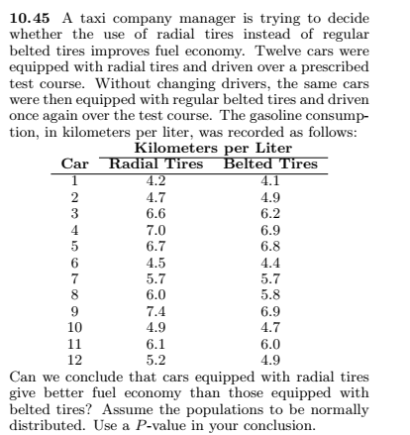

**Q15)**

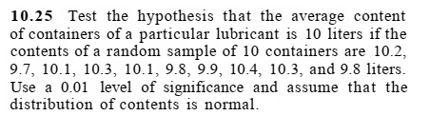

**Q16)**

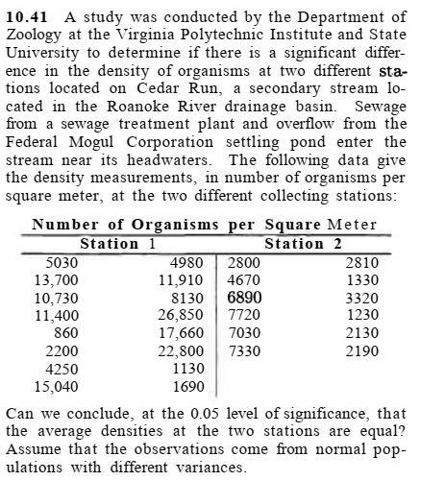

**Q17)**

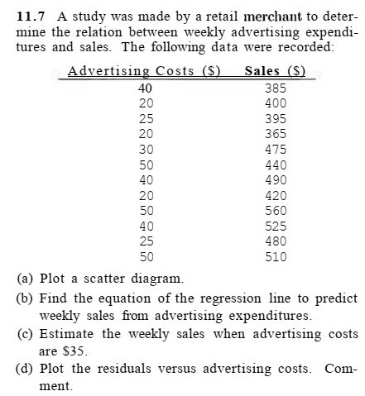

**Q18)**

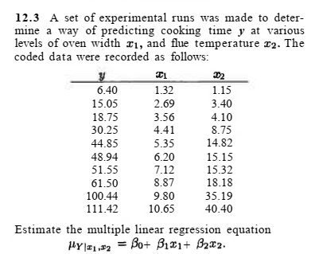

**Q19)**

